CHE517 ADVANCED PROCESS CONTROL
FINAL EXAM
Professor Shi-Shang Jang Jan. 9, 2003

Problem #1 Interpretation (20%)

- Principle of Internal Model Control (Three Properties) 10%
- Regulation Control, Servo Control 5%
- Override Control, Ratio Control

Problem #2 (20%)

The outlet temperature of the process fluid and the oxygen in the flue gas can be controlled in the fired heater in the following figure by adjusting the fuel pressure (flow) and the stack dumper % open. A dynamic model for the fired heater in the following figure was reported by Zhuang et al.(1987) and is repeated here:
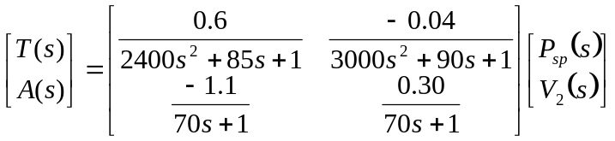
The inputs and outputs are in percent of the range of each instrument, and the time is in sec.
- Determine whether the input output combination is controllable.
- Determine whether either loop pairing can be eliminated based on the sign of the relative gains.
- Determine whether decoupling will improve the control performance.

Problem #3 (20%)

Derive a pulse transfer function (z-domain) for the following plants with a zero order hold and a sampling time of 1:
- 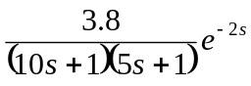 (7 points)
- 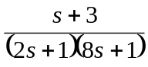 (7 points)
- 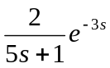 (6 points)

Problem #4 (20%)
(a) Develop a feedforward-feedback control system for a process with the following transfer functions;
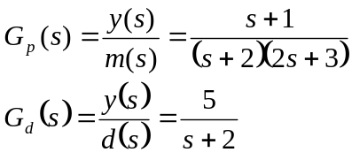
The following specifications are also given: (1) use a PI controller for the feedback loop, and (2) the feedforward system should have both disturbance rejection and set point tracking capabilities.

(b) Show how would tune the feedback PI controller.
(c ) Derive the conditions that must be satisfied in order to have stable closed-loop response. Do these conditions depend on both feedforward and feedback characteristics?

Problem #5 (40%) Take Home MATLAB Problem

Consider a plant with a transfer function of 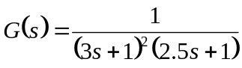, however, someone derives a model for that plant by 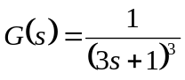 through experiments.
- Derive a discrete model for that plant using a sampling time of 1 time unit.
- Derive a deadbeat controller for the set point suddenly jumped to 1. Is the controller stable? Why?
- Derive a MPC controller for that plant using the model. Is the controller stable? Modify it.
- With a modeling error tune the filter constant α such that the system behaves appropriately.

All the answer for the above questions should be demonstrated by MATLAB simulations.

